Studying Subjective Well-Being during a Quarantine:

How does a weekly gratitude letter affect daily mood states?

Samuel L. Browning1, E. Scott Geller2
1Virginia Polytechnic Institute and State University

May 15, 2021

Abstract

To investigate the impact of writing a gratitude letter on particular mood states, we asked students in two university classes (a research class and a positive psychology class) to complete a 15-item mood assessment survey (MAS) twice a day (once in the morning and once at night). The research students who signed up for one or two pass/fail field-study credits in a research class also completed the MAS twice a day, but they did not write the weekly gratitude letter that was expected from the students in the positive psychology class. Each mood state was averaged per each day for the participants in each group and compared between the Gratitude Group and the Control Group. No group difference occurred for some mood states like “incompetent,” but for the “unmotivated” mood state, a significant difference was found. To investigate the potential effect of weekday, we compared the average mood rating between groups for each day of the week. For the mood state of “unmotivated”, a remarkable dip occurred on Wednesday for the Gratitude group, but not for the Control group. These results indicated that writing a gratitude letter increased the benefactor’s motivation, especially on the day when it was accomplished.

Introduction
In the middle of the semester, Virginia Tech decided to shut down the campus in response to the COVID-19 pandemic. As a result, all course work was encouraged to be made available online, which ultimately swayed students from returning to campus. Research at the Center for Applied Behavior Systems (CABS) necessarily came to a halt and additionally the Positive Psychology course needed modification for online learning. Because both classes were intended to provide students experiential learning, transitioning to online learning was inherently problematic.

Methods

To ameliorate both issues, we offered a research opportunity to both sets of students, which entailed completing a 15-item mood assessment survey (MAS) twice a day (once in the morning and once at night). To investigate the impact of writing a gratitude letter on particular mood states we assigned the students in the positive psychology class to write a weekly gratitude letter—a letter to thank someone for a kind deed—every Wednesday evening. Two sample gratitude letters are provided at the end of this research summary. Students in the Gratitude group (n=21) and the Control group (n=12) completed the MAS twice on 34 consecutive weekdays. Although Figure 1 depicts the mood-scale as displayed on a smart-phone, the students could also complete the survey on a computer or laptop.

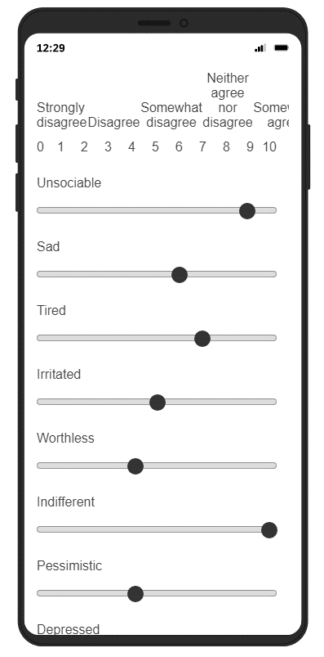
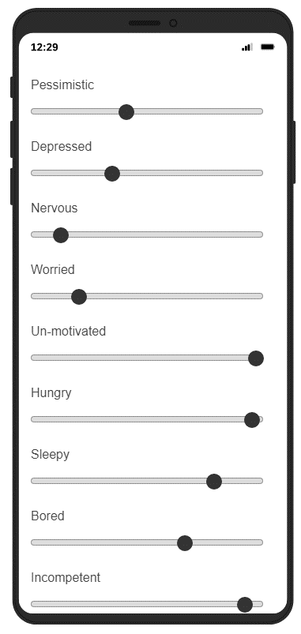
Figure 1. The 15-item mood assessment survey as displayed on a smart-phone

Results

Each mood state was averaged per each day for the participants in each group and compared between the Gratitude group and the Control group. No group differences occurred for some mood states like “incompetent” (Figure 2), but for the “unmotivated” mood state (Figure 3) a noticeable difference was found. Figure 3 depicts the average rating for “unmotivated” across the 34 days and shows an overall increase in the “unmotivated” mood state for both groups as the quarantine progressed. Despite this similarity between both groups, the unmotivated rating was on average lower for the Gratitude group across all 34 days, and this difference between the mood-state ratings of the two groups increased as the quarantine progressed.

Figure 2. The average rating for “incompetent” across time for both groups

Figure 3. The average rating for “unmotivated” across time for both groups

To investigate a potential effect of weekday, we compared the average mood rating between groups for each day of the week. Figure 4 depicts these daily averages per the Gratitude and Control groups for the “unmotivated” mood state. A notable dip occurred on Wednesday for the Gratitude group (i.e., an increase in motivation), but not for the Control group. The Gratitude group also shows an increase in motivation on Fridays, not found for the Control group.

Figure 4. The average “unmotivated” rating on each weekday for both groups

Conclusions

These results indicated that writing the gratitude letter increased the benefactor’s motivation, especially on the day when it was due. However, writing the gratitude letter had no effect on other daily mood-states, like “incompetence.” Further statistical analysis is required to determine whether these differences are statistically significant. An exploratory factor analysis will be conducted on the MAS to determine what independent mood states were assessed with this scale. Then a 2 group (Gratitude vs. Control) x 34 days mixed-factor MANOVA will be conducted per each of the factors. This study will be refined and replicated with both CABS research students and students in the Positive Psychology course during spring semester 2021.

Figure 5. Two sample gratitude letters from anonymous students
