Divergent Levels of Functional Connectivity Between Black Americans and Nonhispanic Whites.

Chinkuli Munkombwe¹, Maria Misiura², Gabriel Martinez¹, Jessica A. Turner²

¹ Neuroscience Institute, Georgia State University, Atlanta, GA

² Department of Psychology, Georgia State University, Atlanta, GA & Center for translational research in neuroimaging and data science, Atlanta, GA

May 12, 2020

Abstract

Black Americans are twice as likely as Nonhispanic Whites to develop Alzheimer’s Disease. In a past study, we found that race modifies the relationship between neuroimaging measures and Alzheimer’s biomarkers between functionally connected regions in the brains of Black Americans. In this study, we aim to replicate these findings in a larger cohort of participants and explore what other factors might be contributing to the observed biomarker-connectivity relationship. We found a marginally significant interaction for race by diagnosis such that Black Americans with dementia had lower connectivity between the precuneus and temporal pole. In contrast, our previous study found that Black Americans had increased connectivity within these regions.

Introduction
Studies have shown that the higher prevalence of Alzheimer’s Disease (AD) in Black Americans can be linked to the modified presence of risk factors between ethnicities. For example, Black Americans are more likely to contract vascular diseases [1], and by extension, have a higher volume of white matter hyperintensities (WMH) in the brain [2]. However, this increased level of risk factors does not adequately explain the neurological differences observed between Black Americans and Nonhispanic Whites.

It is common in studies involving AD to employ functional Magnetic Resonance Imaging (fMRI) to study correlated Blood Oxygen Level Dependent (BOLD) signal between Default Mode Network (DMN) subsystems. The DMN is a useful imaging biomarker for AD made up of the precuneus, posterior cingulate cortex (PCC), the inferior parietal lobule (IPL), and the ventromedial prefrontal cortex (vmPFC) [3]. These brain areas are helpful when studying AD because they are the most vulnerable to atrophy and show correlated longitudinal change in functional connectivity as the disease progresses. Therefore, functional connectivity in the DMN can also be used to track disease progression both before and after the onset of symptoms.

A past study demonstrated that there is a racial difference in the relationship between connectivity in the DMN and typical AD biomarkers [4]. We suspect that these differences would correlate with the variance in disease progression between races as well as the modified neurological relationships. In this study, we aimed to replicate these findings to strengthen this hypothesis further and identify what changes in the brain are unique to race.

Methods
Participants
This study analyzed data from the Open Access of Imaging Studies (OASIS-3) dataset [5]. OASIS-3 is a longitudinal neuroimaging, clinical, cognitive, and biomarker dataset for normal aging and Alzheimer’s Disease. This dataset contained participants that self-reported their race and fell on the diagnostic spectrum of AD. Participants were classified as having either Normal Cognition (NC), Mild Cognitive Impairment (MCI), or AD dementia.

The demographic table for participants included in the OASIS-3 dataset is shown below.

Table 1.
Number of Nonhispanic White or Black Americans with either normal cognition or cognitive impairment.
 | Normal Cognition | Cognitively impaired
NHW | 511 | 195
BA | 94 | 39

Table 2.
Mean age and number of participants who were either male or female.
 | Normal Cognition |  | Cognitively Impaired
Mean (SD) | BA | NHW | BA | NHW
Age | 66.9 (9.25) | 66.8 (9.63) | 76.6 (8.09) | 73.3 (7.01)
Sex (M/F) | 27/66 | 217/294 | 17/20 | 111/81

Table 3.

Number of participants having either normal cognition (NC) or dementia who were male (M) or female (F), along with the number of those who were Black American (BA) or Nonhispanic white (NHW), and the mean age and standard deviation under these diagnostic categories.
 | NC | Dementia
M/F | 246/359 | 130/104
BA/NHW | 94/511 | 39/195
Age (SD) | 66.8(9.56) | 73.8(7.28)

MRI acquisition and preprocessing.
We preprocessed the fMRI data using statistical parametric mapping (SPM12, http://www.fil.ion.ucl.ac.uk/spm/) under MATLAB 2016 environment. A rigid body motion correction was performed using the toolbox in SPM to correct subject head motion, followed by the slice-timing correction to account for timing difference in slice acquisition. The fMRI data were subsequently warped into the standard Montreal Neurological Institute (MNI) space using an echo-planar imaging (EPI) template and were slightly resampled to 3 × 3 ×3 mm³ isotropic voxels. The resampled fMRI images were smoothed using a Gaussian kernel with a full width at half maximum (FWHM) = 6 mm. We performed nuisance covariate regression using the Group ICA of fMRI Toolbox (GIfT).
Seed-based connectivity
Connectivity analyses were performed using FSL. First, we created seed maps using the coordinates from Andrews-Hanna et al., 2010 and created seed maps from these coordinates. We then obtained the time course for each seed for each person using FSL. We correlated these time courses to obtain connectivity measures and performed Fisher z transformation on these raw correlation values.
Statistical analyses
We constructed a linear model with precuneus to temporal pole connectivity as our outcome measure, race and diagnosis are our fixed effects, and included race x diagnosis as an interaction term. Our nuisance variables were gender and race.

Results

There was not a significant main effect of diagnosis (B= 1.908, t (5, 823) = 0.919, p=0.091). We identified a marginally significant interaction of race X diagnosis (B= 1.908, t (5, 833,) = -1.437, p= 0.01)

Fig 1. Functional connectivity between the precuneus and temporal pole

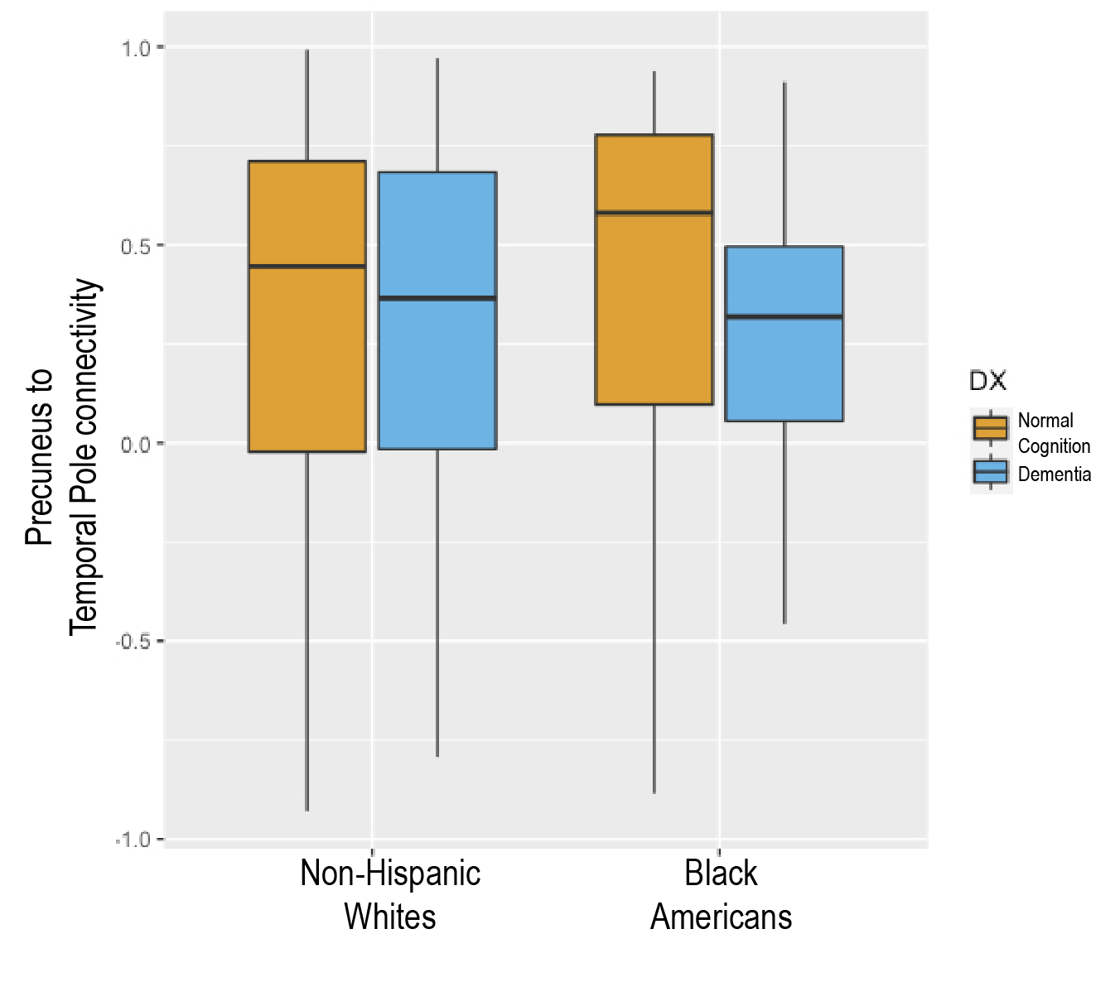

Conclusions

We identified a marginally significant interaction for race x diagnosis such that in black Americans, connectivity was lower in those with dementia than those with normal cognition between the precuneus and temporal pole. In the previous analysis, Black Americans with dementia had increased connectivity between these regions. The lower connectivity is more in line with what we would expect for black Americans as the higher rates of vascular disease coupled with Alzheimer’s pathology may lead to lower functional connectivity in the presence of dementia.
In future studies, we hope to include typical AD biomarkers such as Amyloidβ-42 and CSF tau to investigate their interaction with race, connectivity, and diagnosis in a large cohort of participants. This study also included far more NHW than Black participants. However, it did include many BA participants so as to be as representative of a large population as possible.
The reasons behind the neurological differences found in Black Americans and Non-Hispanic whites with AD and the different presentations of the disease warrant further study. Not only do studies like this one provide neurological support for race being considered an important factor in diagnosis and other investigations involving AD, but they also create a more apparent avenue to understanding and mitigating the disease.

References

- Wei, P., Milbauer, L., Enenstein, J. et al. Differential endothelial cell gene expression by African Americans versus Caucasian Americans: a possible contribution to health disparity in vascular disease and cancer. BMC Med 9, 2 (2011). https://doi.org/10.1186/1741-7015-9-2
- Barnes, L. L., & Bennett, D. A. Alzheimer’s disease In African Americans: Risk factors and challenges for the future. Health Affairs, 33(4), 580-586. (2014).doi:10.1377/hlthaff.2013.1353
- Andrews-Hanna JR, Reidler JS, Sepulcre J, Poulin R, Buckner RL. Functional-anatomic fractionation of the brain's default network. Neuron. (2010);65(4):550-562. doi:10.1016/j.neuron.2010.02.005
- Misiura, M.B., Howell, J.C., Wu, J. et al. Race modifies default mode connectivity in Alzheimer’s disease. Transl Neurodegener 9, 8 (2020). https://doi.org/10.1186/s40035-020-0186-4
- Pamela J LaMontagne, Tammie L.S. Benzinger, John C. Morris, Sarah Keefe, Russ Hornbeck, Chengjie Xiong, Elizabeth Grant, Jason Hassenstab, Krista Moulder, Andrei Vlassenko, Marcus E. Raichle, Carlos Cruchaga, Daniel Marcus, OASIS-3: Longitudinal Neuroimaging, Clinical, and Cognitive Dataset for Normal Aging and Alzheimer Disease. (2019). medRxiv. doi: 10.1101/2019.12.13.19014902

