A Hybrid Synthetic Aperture and Time-Reversal MUSIC Algorithm for Subwavelength Radar Imaging

Nathaniel Tamminga1, Brianna Christensen1, Sarah Petry1, and Enson Chang1
1Azusa Pacific University

February 22, 2021

Abstract
promising chipless RFID approach uses millimeter-wave synthetic aperture radar (SAR) to image metal ink-printed ID tags from a meter or more away. Due to printing cost, it is desirable to minimize the size and spacing of metal patches within a tag, preferably into the subwavelength regime. Although circular SAR (CSAR) has a sharply peaked point response in 2D, its side lobes of closely-spaced targets interfere strongly with each other to distort the image. An alternative 2D subwavelength imaging approach with minimal side lobes is Time-Reversal MUSIC (TR-MUSIC). Traditional TR-MUSIC, however, requires a large number of transmitters and receivers. We propose a hybrid synthetic aperture TR-MUSIC algorithm (SATR-MUSIC) that combines the benefits of both approaches. Using relatively few transceivers, SATR-MUSIC is able to resolve objects separated by approximately $0.35λ$ in 2D with minimal background artifacts. It does so by averaging TR-MUSIC’s imaging kernel incoherently over the synthetic aperture.
A

Introduction
A promising chipless Radio Frequency Identification (RFID) approach uses short-range millimeter wave radar in the 24 to $>80$ GHz regime to image small, printed metal patches in an ID tag, as described by several U.S. patents [1,2]. The readout range can be a meter or more, providing substantial flexibility in readout architecture and logistics. Making such a concept viable, however, involves interesting signal processing challenges.
Printing cost considerations require the patches to be closely packed within a space comparable to V- or W-band radar wavelength, implying an imaging array comparable in size to the readout range. Synthetic aperture radar (SAR) [3,4] can achieve such a large aperture at reasonable cost. A variety of SAR configurations may be appropriate for chipless RFID, such as circular SAR (CSAR). CSAR is potentially attractive for this application because of its bandwidth-independent subwavelength resolution in 2D [5,6]. However, side lobes of closely spaced patches interfere with each other strongly to distort image [7].
An alternative imaging approach in the subwavelength regime is time-reversal multiple signal classification (TR-MUSIC) [8-10]. It is a derivative of the traditional MUSIC algorithm [11,12], an eigenspace method capable of super-resolving a signal’s direction of arrival (DOA). TR-MUSIC shares similar characteristics, able to resolve the 2D or 3D position of a scatterer beyond the diffraction limit, even to the subwavelength level. Under noise-free conditions, TR-MUSIC can produce an infinitely sharp point response without any side lobe. TR-MUSIC’s applicability to the RFID problem is limited in several ways. First of all, TR-MUSIC requires equal or comparable numbers of transmitters and receivers, adding to system cost. Secondly, the transceivers (assuming collocated transmitters and receivers) spacing in a linear array must be less than λ/2 to avoid grating lobes. Since TR-MUSIC is highly sensitive to noise unless the targets are in the array’s near-field, large standoff requires a large linear array. A full-aspect (circular) array surrounding the target area requires less but still a significant number of transceivers to avoid grating lobes.
We propose a hybrid synthetic aperture TR-MUSIC (SATR-MUSIC) algorithm that combines the benefits of both synthetic aperture and TR-MUSIC. The analysis below will concentrate on the full-aspect geometry in which the target area rotates relative to fixed sensors. Although the system uses a highly sparse array of sensors, grating lobes are suppressed by summing over the synthetic aperture. For realistic noise levels, SATR-MUSIC is able to achieve image resolution close to $λ/3$ with minimal side or grating lobes. Since TR-MUSIC literature differentiates between super- and subwavelength-resolution, we emphasize that the latter is the goal here.

Theoretical Background
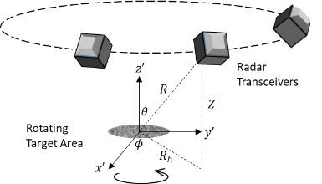
This paper will analyze the sensor configuration shown in Fig. 1. This configuration uses several transceivers (not all shown) in a circular ring above the target area. The area rotates through $2π/N$ radians, where $N$ is the number of regularly spaced sensors. At each angular position, each trasceiver transmits in turn while all sensors receive the scattered signal.
Figure 1. This is the full-aspect (circular) sensor configuration with a ring of sensors centered above a rotating target area.
If the system only operates at a single frequency, the traditional TR-MUSIC forms an image using the following pseudospectrum [8]
$$\begin{aligned}\begin{aligned}P\left(X_{p}\right)=\frac{1}{\sum_{i,null}{{\left|u_{i}^{†}g\left(X_{p}\right)\right|}^{2}}}\#\end{aligned}\#\left(1\right)\end{aligned}$$
where $X_{p}$ is an image location, and the sum is over the null-space singular vectors of the time-reversal matrix (see [8]), $g\left(X_{p}\right)$ is the Green’s function vector, and $u_{i}$ is the ith null-space singular vectors. The imaging process comprises testing different hypothetical target locations, $X_{p}$. When $X_{p}$ is not a target location, it belongs to the null subspace so that the sum is nonzero. When $X_{p}$ is a target location, the sum is zero so that the image peaks sharply. The target locations, however, fluctuate significantly in the presence of noise. An incoherent sum over frequency is frequently effected to stabilize the image [13], at the expense of large system bandwidth.
Our RFID application’s main goal is to replace spectral with spatial averaging, in order to minimize the number of sensors and bandwidth. The best chance for combating noise is then to adopt the full-aspect configuration so that the targets are always in the near field of the array. The SATR-MUSIC pseudospectra analogous to the spectrally averaged version in [13] are:

$$\begin{aligned}\begin{aligned}P\left(X_{p}\right)=\frac{1}{\frac{1}{N_{ϕ}}\sum_{ϕ}{\sum_{i,null}{\frac{{\left|u_{i}^{†}g\left(X_{p}\right)\right|}^{2}}{{\left\|g\left(X_{p}\right)\right\|}^{2}}}}}\#\end{aligned}\#\left(2\right)\end{aligned}$$

$$\begin{aligned}\begin{aligned}P\left(X_{p}\right)=\frac{1}{1-\frac{1}{N_{ϕ}}\sum_{ϕ}{\sum_{i,signal}{\frac{{\left|u_{i}^{†}g\left(X_{p}\right)\right|}^{2}}{{\left\|g\left(X_{p}\right)\right\|}^{2}}}}}\end{aligned}\#\left(3\right)\end{aligned}$$

where the sum with respect to rotation angle $ϕ$ is carried out over $N_{ϕ}$ discrete angles. In Eqs. 2 and 3 the inner sum is over those singular vectors that span the signal space. Although the singular vectors form a complete orthonormal basis of the $N$-dimensional complex vector space $C^{N}$, the two forms above are similar but not identical in the presence of noise. The analysis below will calculate the pseudospectrum with Eq. 2 when the number of targets, $M$, satisfies $M<N$ and Eq. 3 when $M=N$. We will also use “image intensity” to refer to the pseudospectrum.

Results
In this section we examine the resolution limit of SATR-MUSIC with Matlab simulation at 79 GHz radar frequency, although the results are presented in a frequency-independent form by using $λ$ as the spatial scale. Figure 2 shows

Figure 2. SATR-MUSIC images of four point targets with (a) $2λ$, (b) $λ$, (c) $λ/2$, and (d) $λ/3$ spacing.
the images of four targets with uniform strength, separated by $2λ,λ,λ/2,$ and $λ/3$. The simulation uses 6 sensors with uniform angular spacing, $R=1m, Z=0.3m$, and includes random white Gaussian noise with 10 dB signal-to-noise ratio (SNR). The sensors rotate by $360°/N$ in $2°$ increments. SATR-MUSIC resolves all but the last case, indicating that SATR-MUSIC’s image resolution is between $λ/2$ and $λ/3$. The more precise point at which the target peaks fail to separate from each other is around $0.35λ$ in this case, although the exact resolution limit depends on SNR and target configuration. In all cases simulated, the grating lobes are strongly suppressed by the synthetic aperture.
Since SATR-MUSIC’s performance depends on target and sensor configurations in a nonlinear fashion, we analyze its performance for a large combination of sensor and target numbers to explore the algorithm’s operating envelope. Other simulation parameters are the same as before. To keep the target region’s $x$ and $y$ extents roughly equal, targets are added to a grid with $λ/2$ spacing in the order shown in Fig. 3a. As an example, Fig. 3b shows the SATR-MUSIC image of three targets imaged by six sensors. The corresponding TR-MUSIC image in 3c does not have the benefit of synthetic aperture averaging, showing poor grating lobes in the form of ghost images.

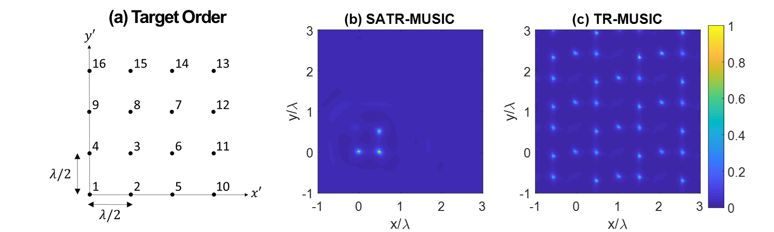
Figure 3. (a) A diagram illustrating the order in which targets are added to the scene. (b) An example SATR-MUSIC image of three targets imaged with six sensors; (c) TR-MUSIC image of the same three targets.
To quantify imaging performance, a square image region of sides $λ/2$, centered at a target’s correct position, is defined to be a target region. The background image is obtained by excising all the target regions. After subtracting the mean background intensity from the image, the peak intensity in each target region is averaged over the targets to obtain the mean target peak intensity. The image’s figure of merit (FOM) is defined to be the ratio of the mean target peak intensity to the peak background intensity:
$$\begin{aligned}\begin{aligned}FOM\left(dB\right)=10\log_{10}{\frac{Meantargetpeakintensity}{Peakbackgroundintensity}}\end{aligned}\#\left(4\right)\end{aligned}$$
The above analysis is performed for $N=2$ to 16 sensors. The number of targets, $M$, ranges from 1 to $N$. SATR-MUSIC FOMs are summarized in Figure 4a on a scale of 0 to 22 dB. The results show almost uniformly high FOM. Although the lowest FOMs occur when $M$ approaches $N$, nearly all sub-diagonal entries (one less target than sensors) exceed 10 dB. Even some of the diagonal entries (equal number of targets and sensors) exceed 10 dB for relatively large number of sensors.

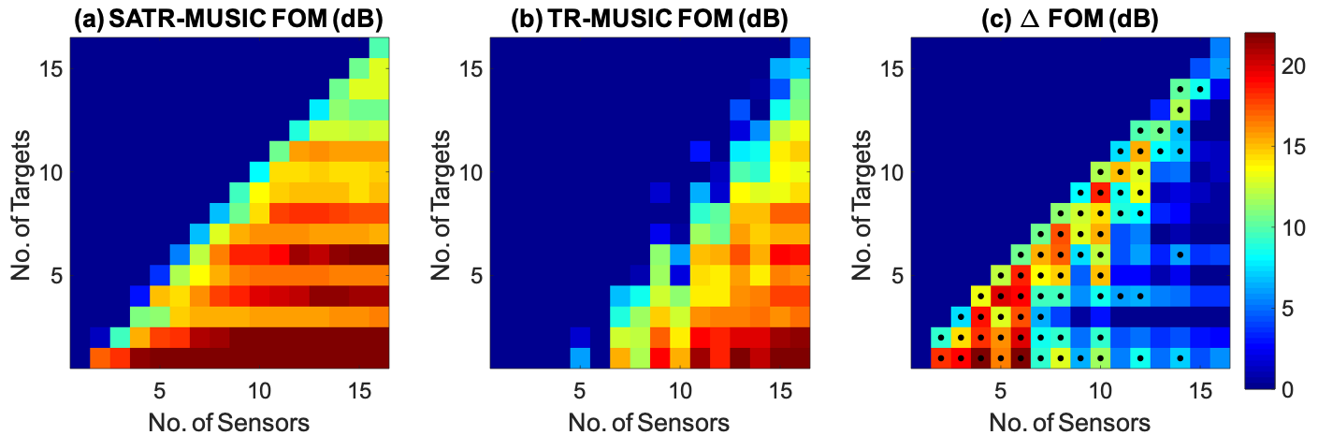

Figure 4. Summary FOMs for different combinations of sensor and target numbers. Target arrangement is described in the text. Since the number of targets cannot exceed the number of sensors, only the lower triangular part is analyzed: (a) SATR-MUSIC FOM; (b) TR-MUSIC FOM for the same cases; (c) difference between the previous two plots, representing SATR-MUSIC’s gain over TR-MUSIC. Those sensor-target combinations with greater than 6 dB gain are marked by black dots.
For comparison, Fig. 4b shows the corresponding TR-MUSIC FOMs. Each FOM is averaged over 30 noise realizations to reduce random fluctuations. The resulting FOMs for $N<7$ are all close to zero dB due to strong grating lobes. When the number of sensors is large enough, TR-MUSIC imagery are grating lobe-free even without the benefit of synthetic aperture. Therefore, SATR-MUSIC’s advantage over TR-MUSIC is most apparent in the regime of small number of sensors. Figure 4c shows the difference between SATR-MUSIC and TR-MUSIC FOMs, representing SATR-MUSIC’s gain over TR-MUSIC. To help visualization, those sensor-target combinations with greater than 6 dB gain are marked by black dots.

Conclusions
This paper has demonstrated significant advantages of SATR-MUSIC over CSAR and TR-MUSIC. CSAR has a sharply peaked point response in 2D, but the side lobes of closely-spaced targets interfere strongly with each other to distort the image. The full-aspect SATR-MUSIC results indicate that this approach can achieve an image resolution close to $λ/3$ in 2D with minimal side lobes, in the presence of realistic noise level. The primary advantage of SATR-MUSIC over traditional TR-MUSIC is its ability to use fewer sensors in a sparse array. SATR-MUSIC suppresses grating lobes by its synthetic aperture. The sensor number advantage and the wide availability of narrowband sensors may be critical for RFID from the cost perspective.
SATR-MUSIC in its current form is not yet a practical, general purpose imaging algorithm for several reasons. Its primary limitation is the constraint on the number of scatterers ($M≤N$). To be useful for other applications it would be highly desirable to overcome this limitation. Secondly, MUSIC-based algorithms are designed to determine source or scatterer location but not their strength. Reference [14] discusses a least squares method to determine target strengths once they are located by TR-MUSIC. SATR-MUSIC may also follow the same approach to determine target strengths in the super-wavelength regime.

References
[1] Pettus, M. RFID system utilizing parametric reflective technology. U.S. Patent 7 460 016, Dec. 2, 2008.
[2] Kofman, S.; Meerfeld, Y.; Sandler, M.; Dukler, S.; Alchanatis, V. Radio frequency identification system and data reading method. U.S. Patent 20090014520A1, Jan. 15, 2009.
[3] Curlander, J.C.; McDonough, R.N. Synthetic Aperture Radar: Systems and Signal Processing, John Wiley & Sons, Chichester, England, 1991.
[4] Carrara, W.G.; Goodman, R.S.; Majewski, R.M. Spotlight Synthetic Aperture Radar Signal Processing Algorithms, Artech House, Boston, MA, USA, 1995.
[5] Soumekh, M. Reconnaissance with slant plane circular SAR imaging. IEEE Trans. Image Process., 1996, Vol. 5, No. 8, pp. 1252-1265.
[6] Ishimaru, A.; Chang, T.; Kuga, Y. An Imaging Technique Using Confocal Circular Synthetic Aperture Radar. IEEE Trans. Geosci. Remote Sens., 1998, Vol. 36, No. 5, pp. 1524-1530.
[7] Guido, N.A.; Hiatt, E.T.; Chang, E. CSAR Imaging of Electromagnetically Coupled Conducting Scatterers. Prog. In Electromagn. Res. M, 2019, Vol. 79, pp. 113-126
[8] Devaney, A.J. Time reversal imaging of obscured targets from multistatic data. IEEE Trans. Antennas Propag., 2005, Vol. 53, No. 5, pp. 1600-1610.
[9] Marendo, E.A.; Gruber, F. K.; Simonetti, F. Time-Reversal MUSIC Imaging of Extended Targets. IEEE Trans. Image Process., 2007, Vol. 16, No. 8, pp. 1967-1984.
[10] Ciuonzo, D.; Romano, G.; Solimenne, R. Performance analysis of time-reversal MUSIC. IEEE Trans. Signal Process., 2015, Vol. 63, No. 10, pp. 2650-2662.
[11] Therrien, C. Discrete Random Signals and Statistical Signal Processing, Prentice Hall, New Jersey, 1992.
[12] Stoica, P.; Moses, R. Introduction to Spectral Analysis, Prentice Hall, New Jersey, 1997.
[13] Lev-Ari, H.; Devaney, A.J. The time-reversal technique re-interpreted: subspace-based signal processing for multistatic target location’, Proceedings of IEEE Sensor Array and Multichannel Signal Processing Workshop, 2000, pp 509-513.
[14] Devaney, A.J.; Marengo, E.A.; Gruber, F.K. Time-reversal-based imaging and inverse scattering of multiply scattering point targets. J. Acoust. Soc. Am., 2005, Vol. 118, No. 5, pp. 3129-3138.

